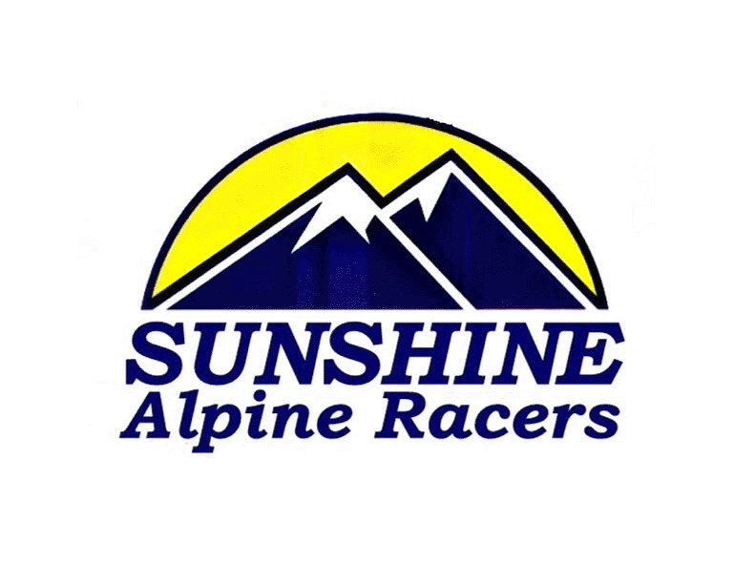

Emergency Consent Form

I , , the parent/guardian of , authorize the Coaching Staff of the Sunshine Alpine Racers consisting of Garrett Wilson to give consent to act on my behalf for all emergency medical and/or surgical treatment that may be required for our child during our absence from September 30 2020 to May 31 2021. I understand the coaches will notify me of the medical treatment as soon as possible, and prior to any non-essential procedures or treatments.

Child’s Name:

Child’s Date of Birth:

Alberta Health Insurance Number:

Other Insurance Info:

Chronic Illnesses:

Allergies: none

Date of Last Tetanus Immunization:

Other Concerns: none

Physician’s Name:

Telephone Number:

Parent Address:
Parent Telephone Numbers (home, cell, work):

Parent Name: __ ________________

Parent Signature: __________________________________

Date: ______________________________

